**MICRO LABS LIMITED**

**Gate Entry Application**

Overview information about current and new features :

1. **Login Page**
2. Location
3. User, password
4. Forgot password (**Module**)
5. Help
6. **Home Page Dash board**
7. Main Menu control
8. Current day visitors details

Name, From, To meet, Time In, Time out, Total time

1. Materials outward details

Material name, Party, Qty, Time in

1. Home | User Details Display | Logout
2. **Visitor Pass**

Note : Financial Year : Apr-Mar

1. **Feature : PHOTO - CAPTURE and SAVE using webcam**

Image width : 3.5 x 4.5 cm

Capture | Image preview | DB Save

1. **Drop Down List**

|  |  |
| --- | --- |
| **VISITOR TYPE** | **PURPOSE OF VISIT** |
| Visitor | Official |
| Supplier | Personal |
| Service Vendor | Material Supply |
| Staff |  |

|  |  |
| --- | --- |
| Name (**Search option**) **\*** | 40 chars |
| Company | 50 chars |
| Address (scroll text) | 100 chars |
| City | 30 chars |
| Email | 30 chars |
| Phone No | 30 chars |
| Person name accompanied | 40 chars |
| No of persons | Numeric |
| Asset belongings (scroll text) | 100 chars |
| Person to be seen | 40 chars |
| Dept (**drop down**) | Emp dept / others |
| Date (display) | System |
| Time In (display) | System |
|  |  |

**\* Name Search** : based on Visitor ID, name, company, person met, date from and to

1. **Visitor Report (criteria based)**
2. Summary
3. Date Range
4. Name

**FEATURES**: In rest of the transaction screens wherever required (**COMMON FIELDS**)

|  |  |
| --- | --- |
| **Additional Details** | **Type** |
| Person Name | 40 chars |
| Transporter Name | 40 chars |
| Vehicle No | 30 chars |
| Remarks | 100 chars |

**EXTERNAL RESOURCE DEPENDENCIES :**

1. PHOTO CAPTURE
2. SAP INTEGRATION
3. MAIL TRIGGER

**DB DETAILS**

**MS-SQL 2008**

|  |  |  |
| --- | --- | --- |
|  |  |  |
| Server Name | MICROHONT16 |  |
| Server IP | 192.168.1.94 |  |
| User name | sa |  |
| Password | micro123# |  |
| Database name | ML_GE |  |
|  |  |  |

**TABLE DETAILS**

**GE_LOCATION**

|  |  |  |
| --- | --- | --- |
| **FIELD_NAME** | **DATA_TYPE** | **ALLOW NULL** |
| LOCATION_ID | NVARCHAR(5) | NOT NULL – PRIMARY KEY |
| LOCATION_NM | NVARCHAR(50) | NOT NULL |
| CREATED_BY | NVARCHAR(35) | NOT NULL |
| CREATED_DATE | DATETIME | NOT NULL |
| MODIFIED_BY | NVARCHAR(35) | NULL |
| MODIFIED_DATE | DATETIME | NULL |

**GE_USER**

|  |  |  |
| --- | --- | --- |
| **FIELD_NAME** | **DATA_TYPE** | **ALLOW NULL** |
| LOCATION_ID | NVARCHAR(5) | NOT NULL |
| USER_ID | INT | NOT NULL – AUTO |
| USER_EMPNO | INT | NOT NULL |
| USER_FULLNAME | NVARCHAR(50) | NOT NULL |
| USER_NAME | NVARCHAR(35) | NOT NULL |
| USER_PASSWORD | NVARCHAR(35) | NOT NULL |
| EMAIL | NVARCHAR(50) | NULL |
| CREATED_BY | NVARCHAR(35) | NOT NULL |
| CREATED_DATE | DATETIME | NOT NULL |
| MODIFIED_BY | NVARCHAR(35) | NULL |
| MODIFIED_DATE | DATETIME | NULL |

**GE_DEPT**

|  |  |  |
| --- | --- | --- |
| **FIELD_NAME** | **DATA_TYPE** | **ALLOW NULL** |
| DEPT_ID | NVARCHAR(5) | NOT NULL |
| DEPT_NM | NVARCHAR(35) | NOT NULL |
| CREATED_BY | NVARCHAR(35) | NOT NULL |
| CREATED_DATE | DATETIME | NOT NULL |
| MODIFIED_BY | NVARCHAR(35) | NULL |
| MODIFIED_DATE | DATETIME | NULL |

|  |  |  |  |
| --- | --- | --- | --- |
| **GE_VISITORS** | | | |
| **Field Name** | **Date Type** | **Allow Null** | **Field Display** |
| GATE_NO | CHAR(2) | NOT NULL |  |
| FIN_YEAR | CHAR(7) | NOT NULL | Drop Down |
| LOCATION_ID | CHAR(4) | NOT NULL |  |
| VISITOR_NO | INT | NOT NULL | Auto Gen |
| VISITOR_TYPE | CHAR(1) | NOT NULL | Drop Down |
| PURPOSE | CHAR(1) | NOT NULL | Drop Down |
| VISITOR_NAME | NVARCHAR(35) | NOT NULL |  |
| COMPANY | NVARCHAR(35) | NOT NULL |  |
| ADDRESS | NVARCHAR(100) | NULL |  |
| PLACE | NVARCHAR(35) | NOT NULL |  |
| CONTACT_NO | NVARCHAR(20) | NULL |  |
| NO_OF_ACCOMPANYING |  |  | Count |
| ACCOMPANYING_NAMES |  |  | Long Text of around 80-100Chars |
| BELONGINGS | NVARCHAR(150) | NULL |  |
| TO_MEET | NVARCHAR(35) | NOT NULL |  |
| DEPARTMENT | NVARCHAR(35) | NULL | Drop Down |
| TIME_IN | DATETIME | NOT NULL | Display |
| TIME_OUT | DATETIME | NULL |  |
| VISITOR_IMAGE | NVARCHAR(MAX) | NULL | Image Capture and Store path |
| CREATED_BY | NVARCHAR(35) | NOT NULL |  |
| CREATED_DATE | DATETIME | NOT NULL |  |

|  |  |  |  |
| --- | --- | --- | --- |
| **GE_MATOUTWARD** | | | |
| **Field Name** | **Date Type** | **Allow Null** | **Field Display** |
| MANDT | CHAR(3) | NOT NULL (PK) | 150 / 500 |
| FIN_YEAR | CHAR(7) | NOT NULL (PK) | DD |
| LOCATION_ID | CHAR(4) | NOT NULL (PK) | HEADER |
| GATE_NO | CHAR(2) | NOT NULL (PK) | HEADER |
| GO_NO | INT | NOT NULL (PK) | REC +1 |
| GO_DATE | DATETIME | NOT NULL |  |
| TIME_IN | CHAR(10) | NULL |  |
| TIME_OUT | CHAR(10) | NOT NULL | SYS TIME |
| DC_NO | NVARCHAR(20) | NULL |  |
| DC_DATE | NVARCHAR(20) | NULL |  |
| SENDING_PERSON | NVARCHAR(35) | NOT NULL |  |
| SENDING_DEPT | NVARCHAR(35) | NOT NULL | DD |
| DESTINATION_NAME | NVARCHAR(35) | NULL |  |
| DESTINATION_PLACE | NVARCHAR(35) | NULL |  |
| DESTINATION_PERSON | NVARCHAR(35) | NULL |  |
| VEHICLE_NO | NVARCHAR(35) | NULL |  |
| DRIVER_NAME | NVARCHAR(35) | NULL |  |
| TRANSPORTER_NAME | NVARCHAR(35) | NULL |  |
| EXP_RETURN_DATE | DATETIME | NULL |  |
| REASON_REMARKS | NVARCHAR(100) | NULL |  |
| DOC_NO | NVARCHAR(20) | NULL |  |
| DOC_DATE | DATETIME | NULL |  |
| PO_NO | CHAR(10) | NULL |  |
| PO_DATE | DATETIME | NULL |  |
| ITEM_NO | INT | NOT NULL (PK) | REC+1 |
| MATERIAL_TYPE | NVARCHAR(15) | NULL | DD |
| ITEM_CODE | NVARCHAR(18) | NULL |  |
| ITEM_DESC | NVARCHAR(50) | NULL |  |
| UOM | CHAR(3) | NULL |  |
| NO_OF_CASES | INT | NULL |  |
| QTY | NUMERIC(10,3) | NULL |  |
| QTY_RCVD | NUMERIC(10,3) | NULL |  |
| CREATED_BY | NVARCHAR(35) | NOT NULL |  |
| CREATED_DATE | DATETIME | NOT NULL |  |
| MODIFIED_BY | NVARCHAR(35) | NULL |  |
| MODIFIED_DATE | DATETIME | NULL |  |
| DELETED_BY | NVARCHAR(35) | NULL |  |
| DELETED_DATE | DATETIME | NULL |  |
| DELETED_FLAG | CHAR(1) | NULL | TRUE |
| DELETED_REASON | NVARCHAR(100) | NULL | REASON MANDATORY |

|  |  |  |  |
| --- | --- | --- | --- |
| **GE_MATINWARD_M** | | | |
| **Field Name** | **Date Type** | **Allow Null** | **Field Display** |
| MANDT | CHAR(3) | NOT NULL | 150 / 500 |
| FIN_YEAR | CHAR(7) | NOT NULL | DD |
| LOCATION_ID | CHAR(4) | NOT NULL | HEADER |
| GATE_NO | CHAR(2) | NOT NULL | HEADER |
| GI_NO | INT | NOT NULL (PK) | REC +1 |
| GI_DATE | DATETIME | NOT NULL |  |
| SUPPLIER_PLACE | NVARCHAR(35) | NULL |  |
| VEHICLE_NO | NVARCHAR(35) | NULL |  |
| TIME_IN | CHAR(10) | NOT NULL |  |
| DOC_NO | NVARCHAR(20) | NULL |  |
| DOC_DATE | DATETIME | NULL |  |
| SUPPLIER_NAME | NVARCHAR(35) | NULL |  |
| DRIVER_NAME | NVARCHAR(35) | NULL |  |
| TRANSPORTER_NAME | NVARCHAR(35) | NULL |  |
| REASON_REMARKS | NVARCHAR(150) | NULL |  |
| ENTERED_BY | NVARCHAR(35) | NULL |  |

|  |  |  |  |
| --- | --- | --- | --- |
| **GE_MATINWARD_D** | | | |
| **Field Name** | **Date Type** | **Allow Null** | **Field Display** |
| GI_NO | INT | NOT NULL | FOREIGN KEY |
| PO_NO | CHAR(10) | NULL |  |
| PO_DATE | DATETIME | NULL |  |
| ITEM_NO | INT | NOT NULL (PK) | REC+1 |
| MAT_TYPE_ID | INT | NULL | DD |
| ITEM_CODE | NVARCHAR(18) | NULL |  |
| ITEM_DESC | NVARCHAR(50) | NULL |  |
| UOM | CHAR(4) | NULL |  |
| NO_OF_CASES | INT | NULL |  |
| QTY | NUMERIC(10,3) | NULL |  |
| QTY_RCVD | NUMERIC(10,3) | NULL |  |
| CREATED_BY | NVARCHAR(35) | NOT NULL |  |
| CREATED_DATE | DATETIME | NOT NULL |  |
| MODIFIED_BY | NVARCHAR(35) | NULL |  |
| MODIFIED_DATE | DATETIME | NULL |  |
| DELETED_BY | NVARCHAR(35) | NULL |  |
| DELETED_DATE | DATETIME | NULL |  |
| DELETED_FLAG | CHAR(1) | NULL | TRUE |
| DELETED_REASON | NVARCHAR(100) | NOT NULL | REASON MANDATORY |

SERVER NAME : MICROHONT06

IP NO. : 192.168.1.5

Web Server : IIS Ver . 7.0

Front End : Visual Studio 5.0

Back End : MS SQL 2005

**GATE ENTRY APPLICATION**

It is a web based application developed in Visual Studio 5.0 using MS SQL 2005 as back end.

It deals with capturing the details of the materials which comes and goes out of the organization.

It also equipped to collect data of visitors who visit organization for various reasons.

Based on the organization location, login can be done and that location inward and outward details can be captured and automation mail has been enabled to send mails about the details selected to the respective personnel.

Below are the detailed information about the navigation in the menu order along with screen shots where ever required.

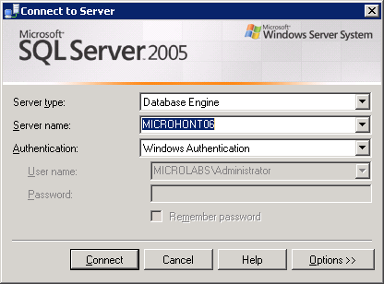DATABASE

Using MS SQL 2005, database has been structured. Windows mode authentication is used to connect to the server.

DATABASE TABLE STRUCTURES

DB Name : Micro_GateEntry

Tables listing is as below

|  |  |
| --- | --- |
|  |  |
| DEPARTMENT_M |  |
| GATE_ENTRY_D |  |
| GATE_ENTRY_M |  |
| GATE_OUTWARD_D |  |
| GATE_OUTWARD_M |  |
| LOCATION_M |  |
| MAIL_M |  |
| Menu |  |
| Menu_Roles |  |
| USER_LOCATION_R |  |
| USER_M |  |
| USER_ROLES_M |  |
| VISITOR_PASS |  |
|  |  |
|  |  |

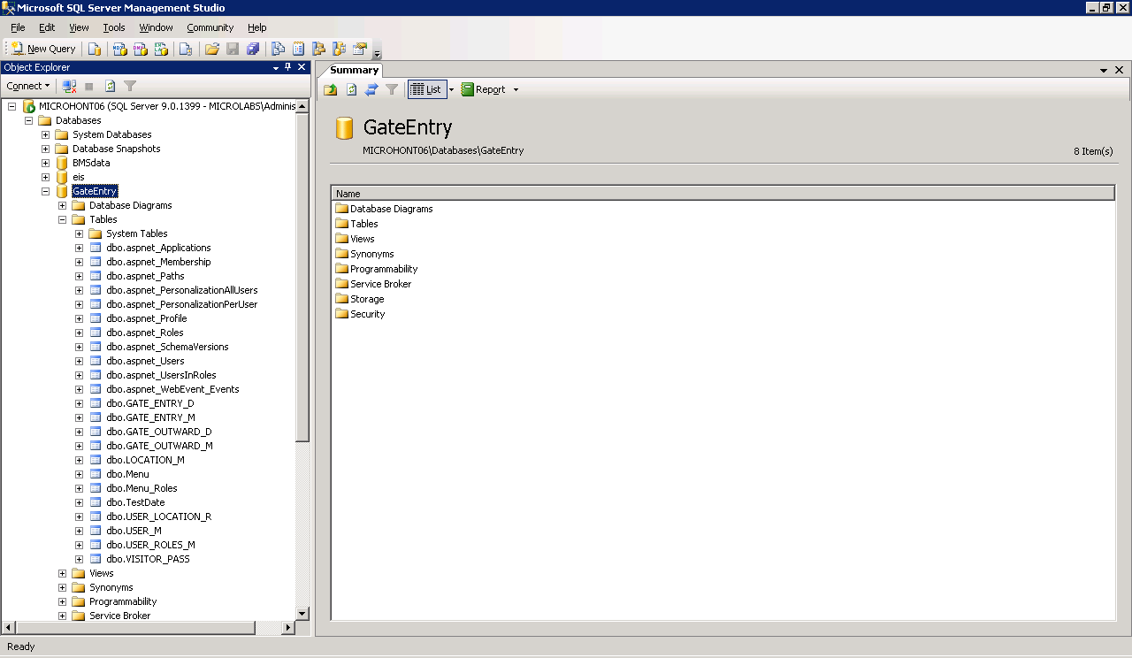

**Login Main screen**

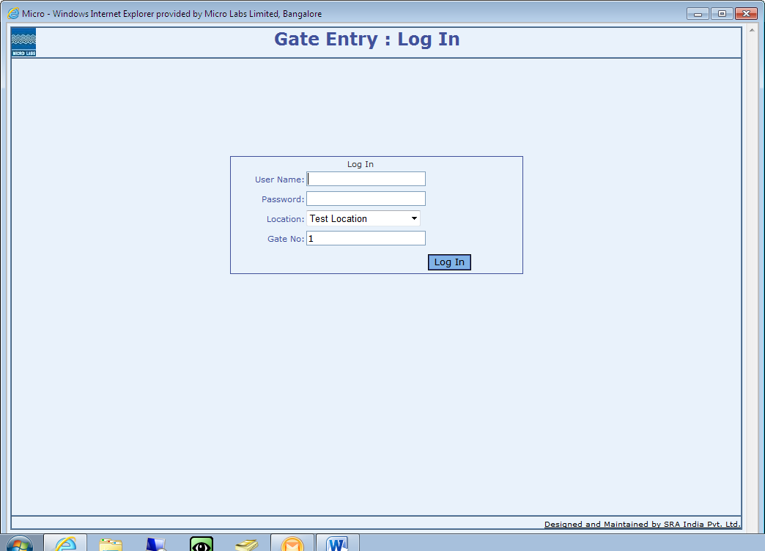**Credentials required**

|  |  |
| --- | --- |
| **User name** | Name |
| **Password** | ****** |
| **Location** | Test Location (Micro Labs Locations List) |
| **Gate No** | 1 (Default Value) |

**Application Main screen**

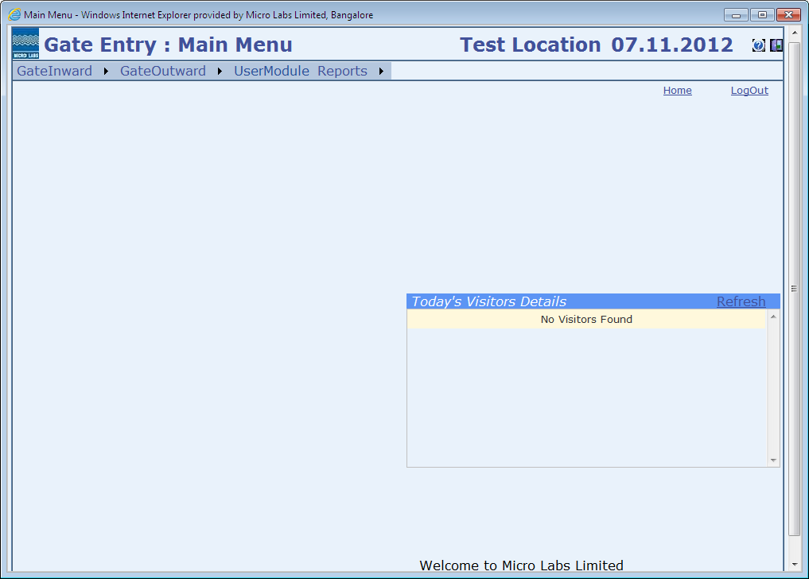

This screen consists of

* Main menu with sub menus explained in detail
* A Fixed window in the right side of the screen which shows details about the visitors of today.
* Refresh button has been provided to update the window for latest details.
* “Scroll title” at the bottom of the screen
* “Home” to return to main screen
* “Logout” to quit the application

**Main Menu Explained**

|  |  |  |  |
| --- | --- | --- | --- |
| **GATE INWARD** | **GATE OUTWARD** | **USER MODULE** | **REPORTS** |
| With P O | Other Materials | Administration | Inward Register |
| Without P O | Excise Invoice |  | Outward Register |
| Returnable Materials | Security Entry |  | Visitor Report |
| Visitor Pass | Sub Contracting (O) |  | Sub-Contract Materials |
| Stock Transfer (I) | Stock Transfer (O) |  | Returnable Materials |
| Sub Contracting (I) | Returnable Mat. Closure |  |  |
| Search Screen | Search Screen |  |  |

**GATE INWARD ->**

**With P O**

Material which comes to factory gate and which have a **Purchase Order No** reference will be entered and saved in this screen.

**PO number** of the logged in **location** has to be entered and details will be pulled from **SAP** and displayed. After complete check, details can be **SAVED / CANCELLED**

**SAP Reference**

|  |  |
| --- | --- |
| **Mandatory Fields** | **Display Fields** |
| Purchase Order No | Location |
| Document Date | Financial Year |
| Entered by | Date |
|  | Inward Time |

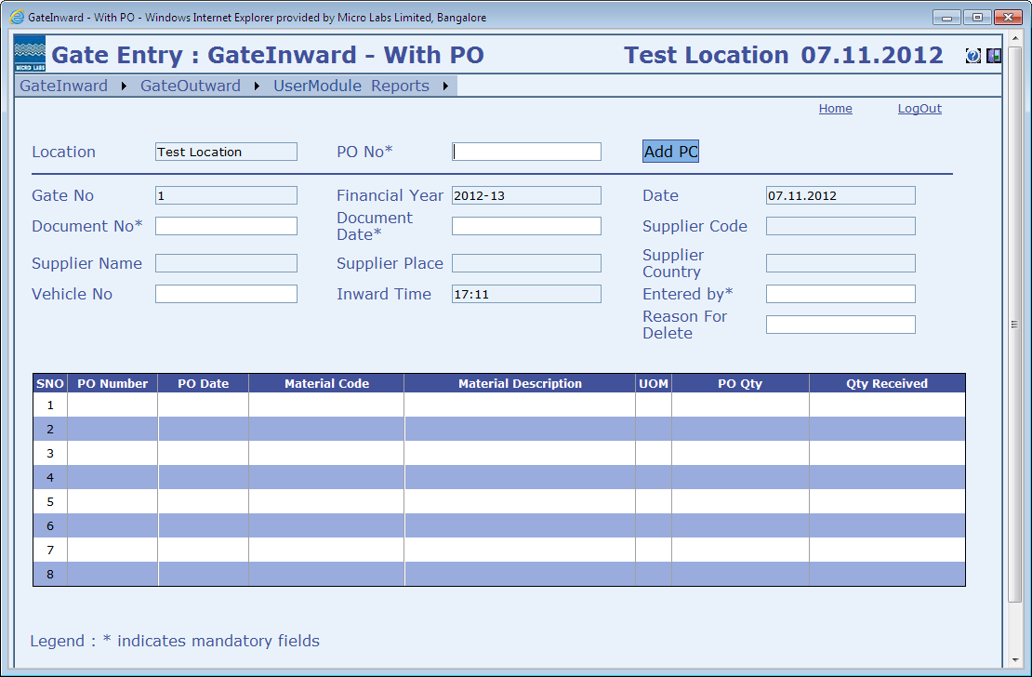

**GATE INWARD ->**

**Without P O**

Materials which comes without a Purchase Order, has to be entered with all the details available.

|  |  |
| --- | --- |
| **Display Fields** | **Material Type List** |
| Location | Raw Material |
| Gate No | Packing Material |
| Financial Year | General Material |
| Date | Maintenance |
| Inward Time | Cash Purchase |

Multiple material details can be added by clicking “**ADD ROWS**” . After complete check, details can be **SAVED / CANCELLED**

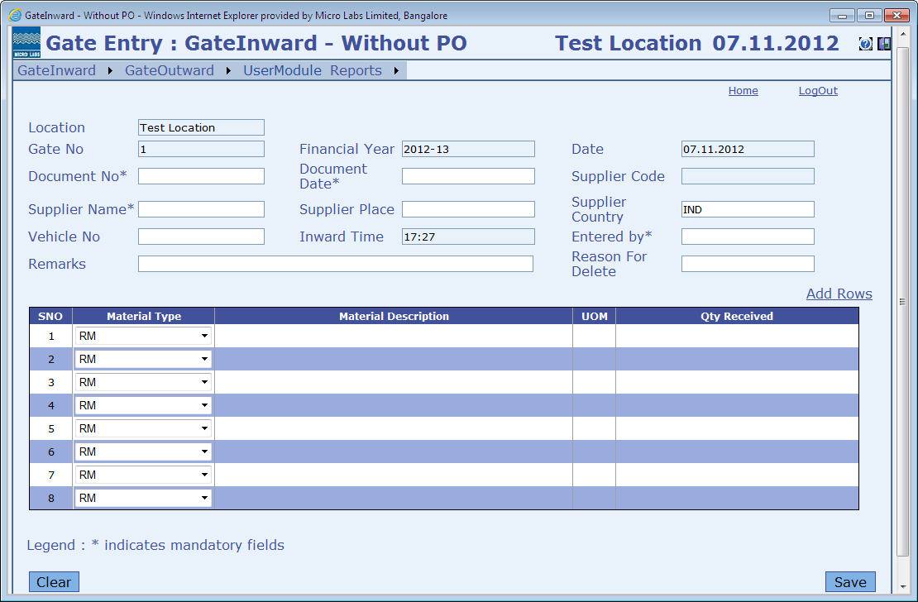

**GATE INWARD ->**

**Returnable Materials**

The material which has gone outside for repair, printing etc., a number will be generated which is a mandatory value for this screen. All the material details will be displayed and name of entry person, vehicle no and reason for delete has to be entered and saved.

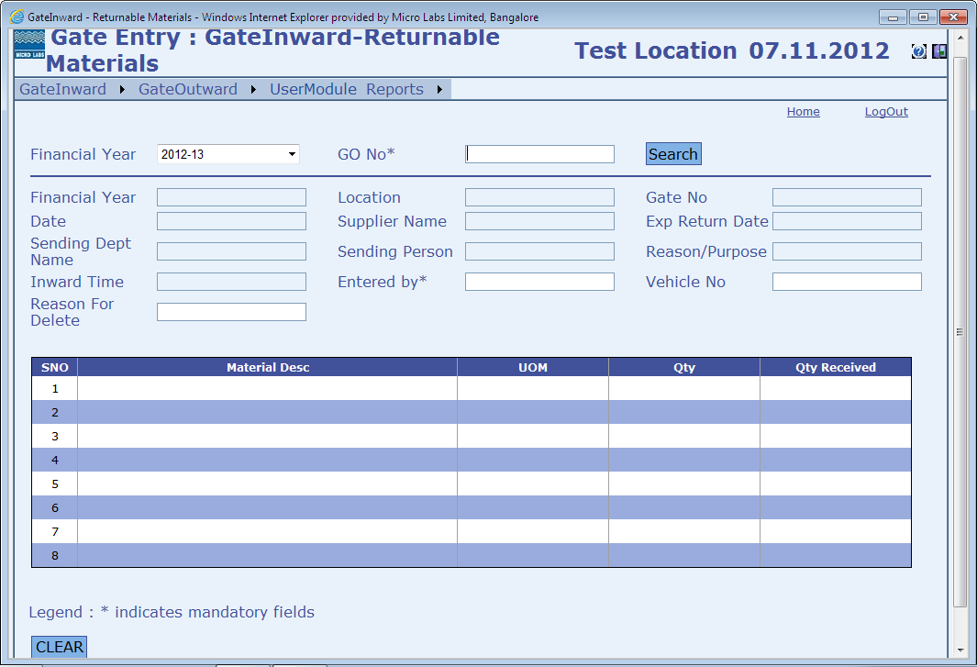

**GATE INWARD ->**

**Visitor Pass**

Any External personal / visitor etc., has to be entered with relevant details and a visitor pass has to be printed using this screen.

|  |  |  |
| --- | --- | --- |
| **Visitor Type** | **Purpose of Visit** | **Department** |
| Visitor | Official | Finance |
| Supplier | Personal | Accounts |
| Service Vendor | Material Supply | IT |
| Staff |  | CQA |
|  |  | Supply Chain |
|  |  | Etc… |
|  |  |  |

A search window provided to search based on visitor name, company etc., which can be used as a ready data to enter in the main entry screen

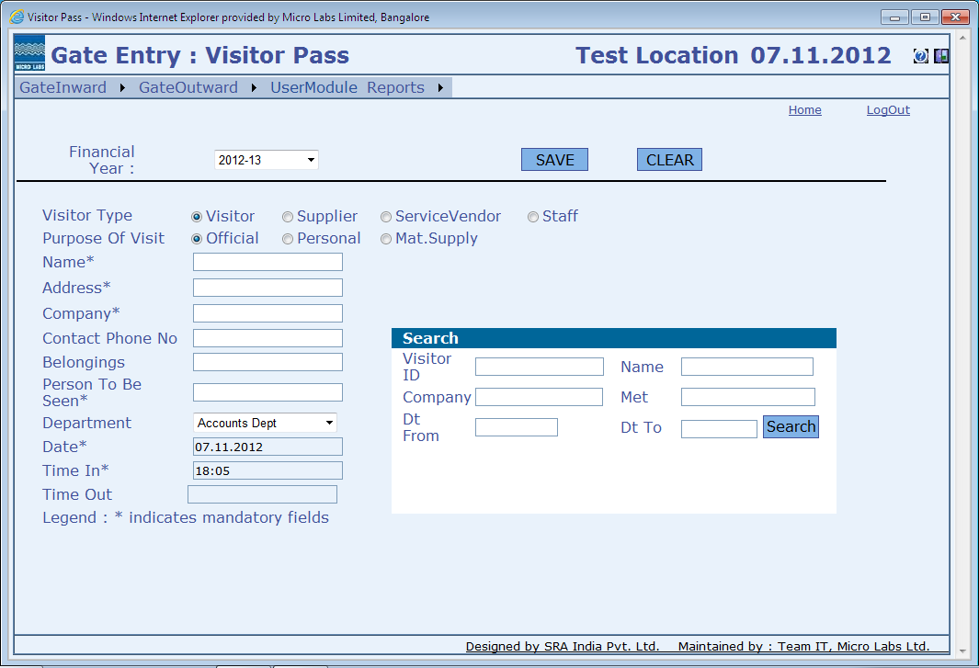

After saving the record, “PRINT” button will be available to take the hard copy of the **visitor pass**

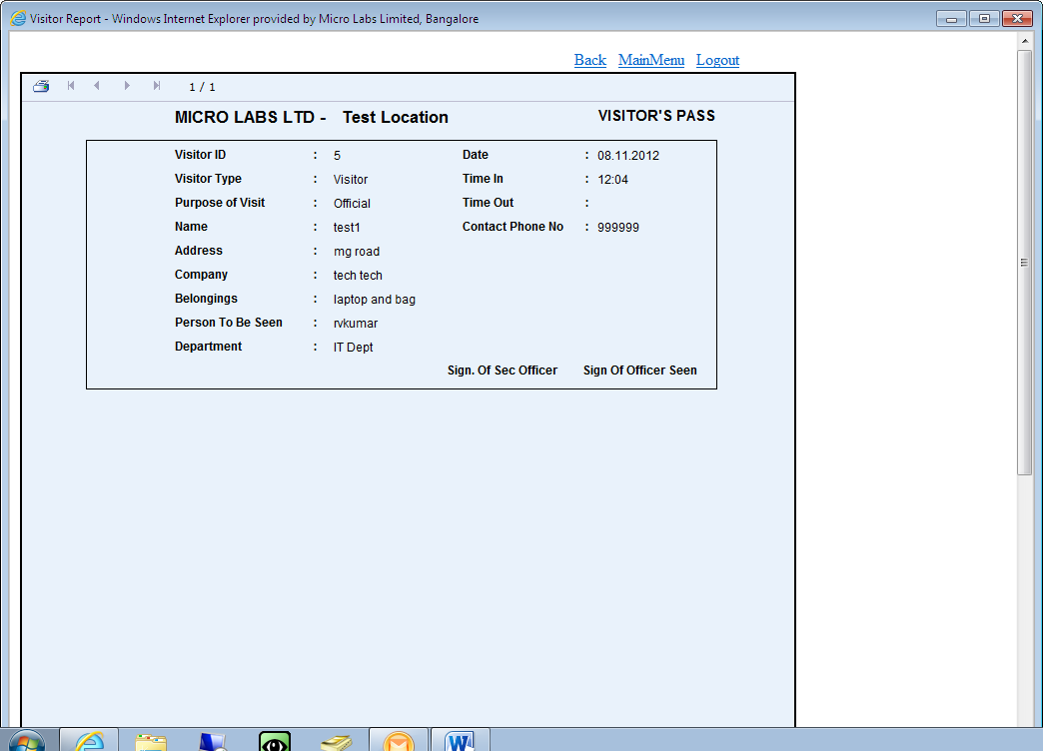

To be printed on a pre-formatted sheet on a dot matrix printer (80 column). After the visit is complete, Sign has to be taken by the visited personal and handed over to security for filing records.

**GATE INWARD ->**

**Stock Transfer**

Any stock to be transferred from one location to another can be captured the this screen.

A Goods outward no has to be provided, based on this details will be populated.

Mandatory fields are : Goods No and Name of the entry person

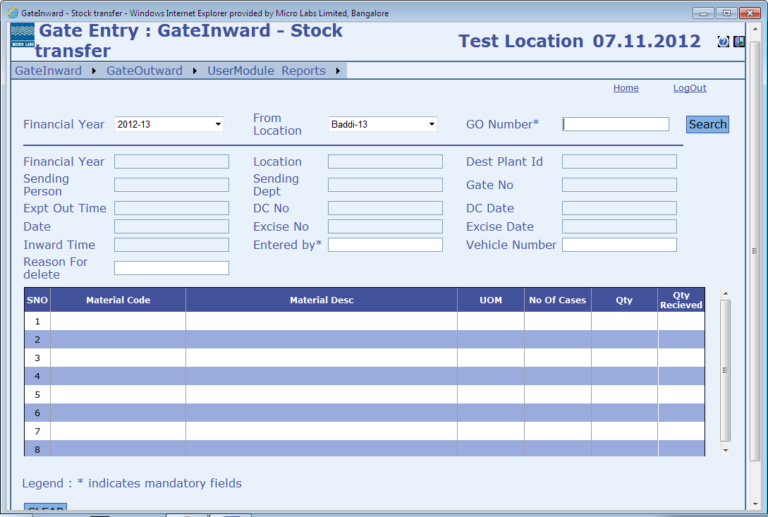

**GATE INWARD ->**

**Sub Contracting**

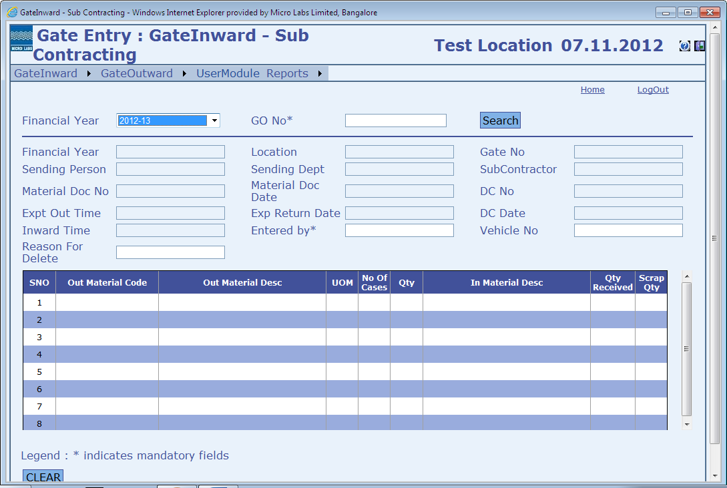

**GATE OUTWARD ->**

**Other Materials**

Any materials other Raw and Packing materials details can be captured in this screen.

Type are : Returnable / Non-Returnable.

Mandatory fields are : Department, Sending Person, GO Type, Destination, Expected Date and Time

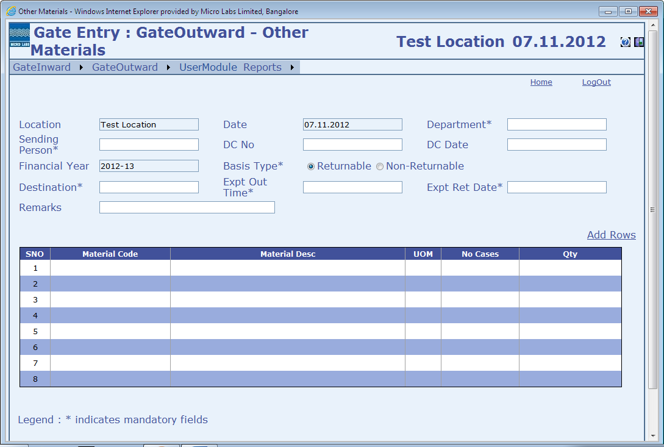

**GATE OUTWARD ->**

**Excise Invoice**

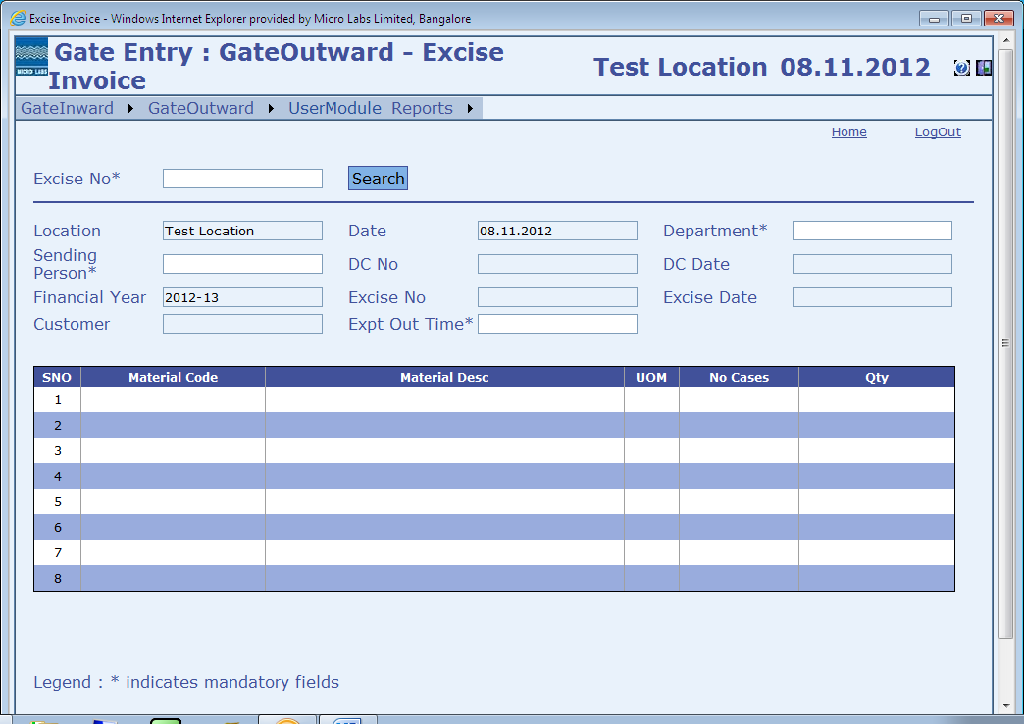

**GATE OUTWARD ->**

**Search**

Based on the search criteria, details will be displayed below the second half of the screen.

Location will be based on the access given to the user who has logged in.

Selection would be based on Document type, Location, Financial Year From and To along with

Goods Outward dates, Delivery Challan Dates, Destination, Department and person name.

|  |  |  |
| --- | --- | --- |
| **Document Type** | **Location (Login Based)** | **Financial Year** |
| Other Materials (Ret) | Baddi | 2012-13 |
| Other Materials (Non-Ret) | Test Location | 2011-12 |
| Sub-Contracting |  | 2010-11 |
| Excise Invoice |  |  |
| Stock Transfer |  |  |

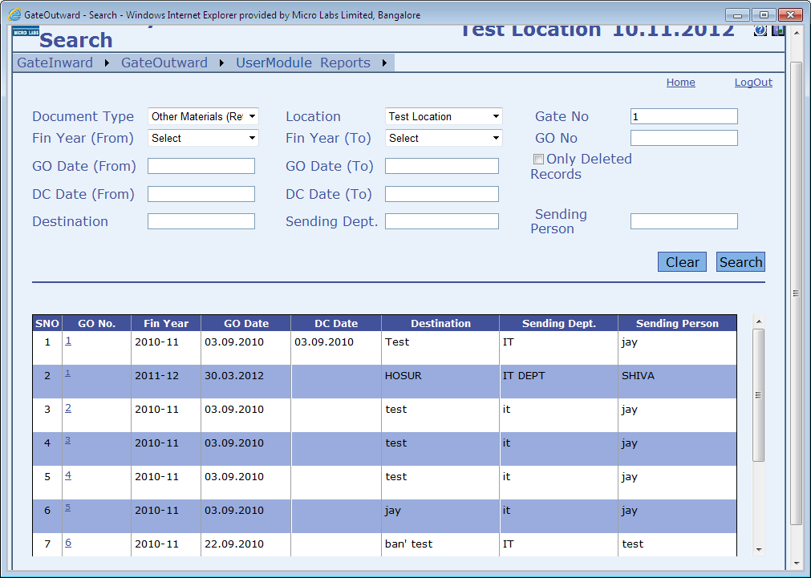Based on the user search, the details will be displayed in the screen above Serial No. wise.

**GATE OUTWARD ->**

**Sub-Contracting (O)**

AUTO MAIL SCHEDULE

Server Program Path : C:\>GateEntry_DailyReport\Micro_DailyReport\Micro_DailyReport\bin\Debug\

File name : Micro_DailyReport.exe

Report Path : C:\>GateEntry_DailyReport\Micro_DailyReport\MailReport\

Report File name Ex : I_ML23_15112012, O_ML13_15112012, V_ML14_15112012

All report file will be in HTML format.

Report Details

Daily at 6.00PM the event is triggered to send the report to the respective personal with their selected report.

Report File name format : V / O / I -> Visitor / Outward / Inward

ML80 -> Location Code

8112012 -> report date

Report Example : 

Creating a System Task using WINDOWS TASK SCHEDULER

TASK NAME : GateEntry_Daily_Report_New

TRIGGER : Daily 6.00PM

STATUS : Enabled

START PROGRAM : C:\>GateEntry_DailyReport\Micro_DailyReport\Micro_DailyReport\bin\Debug\Micro_DailyReport.exe

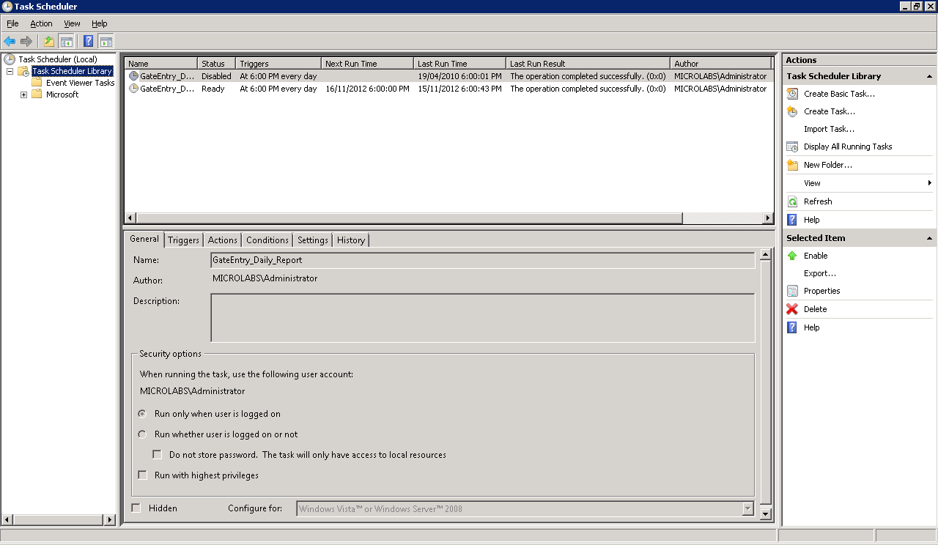

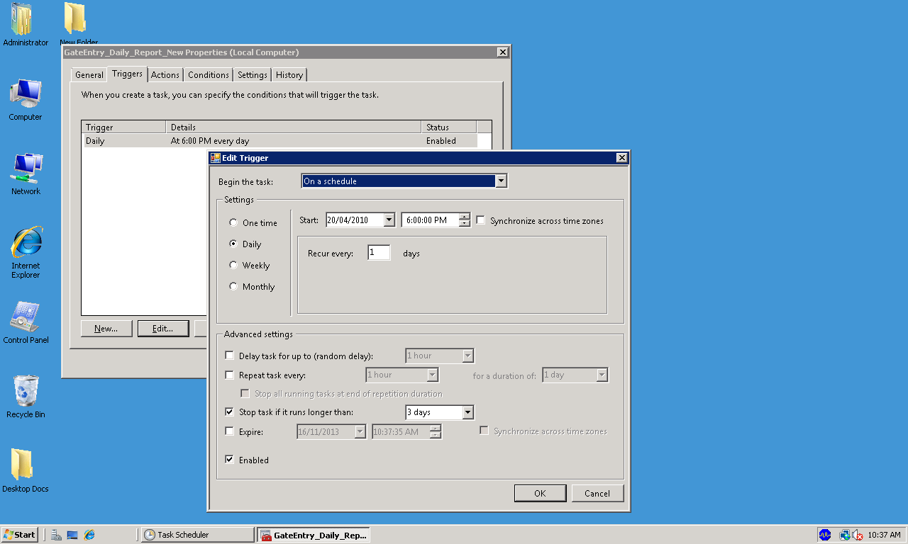Task Scheduler 1

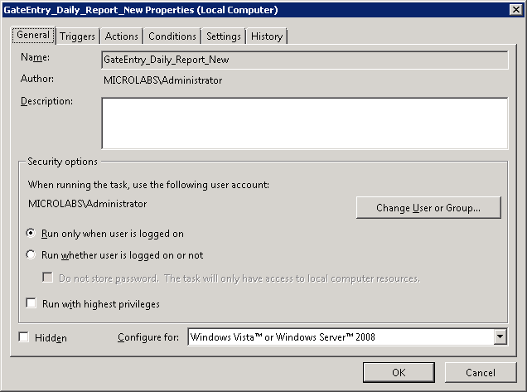

Task Scheduler 2

Task Scheduler 3

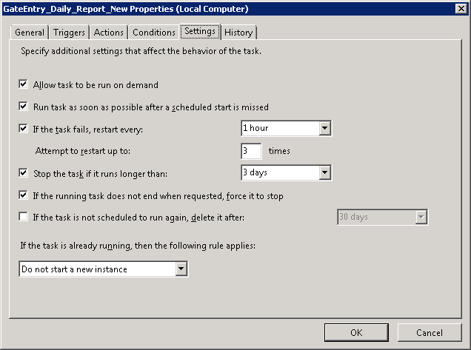

Task Scheduler 4